Transmission Fluid Temperature Gauge – CGEA1.3

Functional Description

The purpose of the Transmission Temperature Gauge is to inform the driver of the vehicle’s transmission temperature. The temperature ranges are designed per RQT-070100-021376 Transmission Temperature Gauge Constraints.

The Transmission Temperature Gauge correlates the Operational Mode and the GboxOil_Te_Actl signal from the TCM to generate pointer movement displaying the vehicle’s transmission temperature in Cold, Normal, Warm and Hot regions. This gauge is normally used on F-series trucks with automatic transmissions. The gauge is typically not available on manual transmission vehicles. Exception is Mustang Cobra (SVT) which has a virtual TFT gauge with a manual transmission (this is handled in Transmission Fluid Temperature Virtual Gauge Display - CGEA1.3 STSS).

The Transmission Temperature Gauge shall be capable of indicating the maximum transmission temperature. The raw input temperature sensor is read by the TCM and then sent via CAN network to the cluster. The cluster then performs damping on the signal to display smooth and continuous pointer movement to the driver. A "flat response" shall be implemented in the Normal operating region. The gauge filters at two different rates outside of the flat zone, depending on engine RPM, input transmission temperature, and ignition time off.

The Transmission Temperature Gauge shall provide an analog gauge with a rotating pointer to indicate the vehicle’s transmission temperature. The Transmission Temperature Gauge pointer shall rotate from bottom to top or left to right to register increasing transmission temperature and rotate in the opposite direction for decreasing transmission temperature.

This gauge typically applies only to automatic transmission vehicles. Thus, it typically is not applied across all cluster variants.

Interfaces

Interface Context Diagram (I/O Block Diagram)
Figure 1.1 Transmission Fluid Temperature Context Diagram
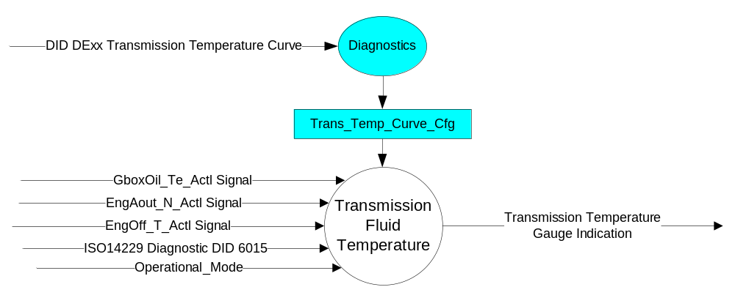

Inputs
- INTERNAL:
  - Operational_Mode: Refer to section Operational Modes
  - Diagnostic DID 6015
  - Trans_Temp_Curve_Cfg
- MUX message on the CAN Bus

- GboxOil_Te_Actl Signal
Signal Name | Size (bits) | Pos. (bits) | Detail | Units | Res. | Offset | State Encoded | Min | Max
GboxOil_Te_Actl | 8 | 24 |  | Deg. C | 1 | -60 |  | -60 (0x0) | 193 (0xFD)
 |  |  | Unknown |  |  |  | 0xFE
 |  |  | Fault |  |  |  | 0xFF

- EngAout_N_Actl Signal
Signal Name | Size  (bits) | Pos.  (bit) | Detail | Units | Res. | Offset | State  Encoded | Min. | Max.
EngAout_N_Actl | 13 | 0 |  | RPM | 2 | 0 |  | 0  (0x0) | 16382  (0x1FFF)

- EngOff_T_Actl Signal
Signal Name | Size  (bits) | Pos.  (bit) | Detail | Units | Res. | Offset | State  Encoded | Min. | Max.
EngOff_T_Actl | 16 | 0 |  | Sec^0.5 | 1 | 0 |  | 0  (0x0) | 65534 (0xFFFE)
 |  |  | Invalid |  |  |  | 0xFFFF

Outputs
- Transmission Temperature Gauge Indication

Function/Performance

Operational Modes

Mode | Differentiating Vehicle Conditions
Sleep Mode | Transmission Temperature Gauge needle at “Rest Position”
Limiting Mode | Transmission Temperature Gauge needle at “Rest Position”
Normal Mode | Transmission Temperature Gauge needle at “Transmission Temperature Gauge”
Crank Mode | Transmission Temperature Gauge needle at “Transmission Temperature Gauge”

Voltage Levels

Refer to Cluster Features table located in the Operational Modes and Voltage Range Strategies section in this SPSS.

Human-Machine Interface

Visual

Indicator Graphics / Display Format
- The "Hot" graduation mark shall be on the right side of the indicating field, except when using a vertically arranged field, in which case the "Hot" graduation shall be on the top of the field.

Indicator Color Coordinates
- It is recommended that the "Hot" graduation mark be colored red.
- The "Cold" graduation may be colored blue.

Indicator Characteristics
Description of Gauge | Scale Range | Scale Span | Operating Span
North American | “C” to “H” | 0 – 86 angular degrees | -4.5 – 88.4 angular degrees (nominal)

Table 1: Transmission Temperature Transfer Function – Table A Config
Operational Mode | GboxOil_Te_Actl Status | Temperature |  | Gauge Pointer (angular degrees) |  |  |  | Position
Operational Mode | GboxOil_Te_Actl Status | ° C | ° F | Target | Min | Max | Delta | Position
Normal or Crank | Pointer Stop | - | - | -4.5 | Pntr stop | -1.5 |  | A
Normal or Crank | 0 – 61 | (-60) – (-1) | -76 – (33.8) | -4.5 | Pntr stop | -1.5 |  | A
Normal or Crank | 70 | 10 | 50 | 0.0 | -3.0 | 3.0 | 6.0 | C
Normal or Crank | 109 | 49 | 120.2 | 8.6 |  |  |  | E
Normal or Crank | 124 | 64 | 147.2 | 36.7 | 34.2 | 39.2 | 5.0 | F
Normal or Crank | 125 – 166 | 65 – 106 | 149.0 – 222.8 | 36.7 | 34.2 | 39.2 | 5.0 | F
Normal or Crank | 167 | 107 | 224.6 | 36.7 | 34.2 | 39.2 | 5.0 | F
Normal or Crank | 187 | 127 | 260.6 | 71.0 |  |  |  | G
Normal or Crank | 189 | 129 | 264.2 | 77.7 |  |  |  | H
Normal or Crank | 191 | 131 | 267.8 | 81.3 |  |  |  | I
Normal or Crank | 192 | 132 | 269.6 | 83.6 |  |  |  | J
Normal or Crank | 195 | 135 | 275 | 86 |  |  |  | K
Normal or Crank | 209 | 149 | 300.2 | 88.4 |  |  |  | L
Normal or Crank | 210 – 253 | 150 – 193 | 302 – 379.4 | 88.4 | 85.4 | 91.4 | 6.0 | L
Normal or Crank | 254 | Unknown | Unknown | -4.5 | Pntr stop | -1.5 |  | A
Normal or Crank | 255 | Fault | Fault | -4.5 | Pntr stop | -1.5 |  | A
All Other Cases |  |  |  | -4.5 | Pntr stop | -1.5 |  | A

Table 2: Transmission Temperature Transfer Function – Table B Config
Operational Mode | GboxOil_Te_Actl Status | Temperature |  | Gauge Pointer (angular degrees) |  |  |  | Position
Operational Mode | GboxOil_Te_Actl Status | ° C | ° F | Target | Min | Max | Delta | Position
Normal or Crank | Pointer Stop | - | - | -4.5 | Pntr stop | -1.5 |  | A
Normal or Crank | 0 – 61 | (-60) – (-1) | -76 – (33.8) | -4.5 | Pntr stop | -1.5 |  | A
Normal or Crank | 70 | 10 | 50 | 0.0 | -3.0 | 3.0 | 6.0 | C
Normal or Crank | 109 | 49 | 120.2 | 8.6 |  |  |  | E
Normal or Crank | 124 | 64 | 147.2 | 36.7 | 34.2 | 39.2 | 5.0 | F
Normal or Crank | 125 – 166 | 65 – 106 | 149.0 – 222.8 | 36.7 | 34.2 | 39.2 | 5.0 | F
Normal or Crank | 167 | 107 | 224.6 | 36.7 | 34.2 | 39.2 | 5.0 | F
Normal or Crank | 185 | 125 | 257 | 71.0 |  |  |  | G
Normal or Crank | 188 | 128 | 262.4 | 77.7 |  |  |  | H
Normal or Crank | 191 | 131 | 267.8 | 81.3 |  |  |  | I
Normal or Crank | 192 | 132 | 269.6 | 83.6 |  |  |  | J
Normal or Crank | 195 | 135 | 275 | 86 |  |  |  | K
Normal or Crank | 209 | 149 | 300.2 | 88.4 |  |  |  | L
Normal or Crank | 210 – 253 | 150 – 193 | 302 – 379.4 | 88.4 | 85.4 | 91.4 | 6.0 | L
Normal or Crank | 254 | Unknown | Unknown | -4.5 | Pntr stop | -1.5 |  | A
Normal or Crank | 255 | Fault | Fault | -4.5 | Pntr stop | -1.5 |  | A
All Other Cases |  |  |  | -4.5 | Pntr stop | -1.5 |  | A

Table 3: Transmission Temperature Transfer Function – Table C Config
Operational Mode | GboxOil_Te_Actl Status | Temperature |  | Gauge Pointer (angular degrees) |  |  |  | Position
Operational Mode | GboxOil_Te_Actl Status | ° C | ° F | Target | Min | Max | Delta | Position
Normal or Crank | Pointer Stop | - | - | -4.5 | Pntr stop | -1.5 |  | A
Normal or Crank | 0 – 61 | (-60) – (-1) | -76 – (33.8) | -4.5 | Pntr stop | -1.5 |  | A
Normal or Crank | 70 | 10 | 50 | 0.0 | -3.0 | 3.0 | 6.0 | C
Normal or Crank | 109 | 49 | 120.2 | 8.6 |  |  |  | E
Normal or Crank | 124 | 64 | 147.2 | 36.7 | 34.2 | 39.2 | 5.0 | F
Normal or Crank | 125 – 166 | 65 – 106 | 149.0 – 222.8 | 36.7 | 34.2 | 39.2 | 5.0 | F
Normal or Crank | 167 | 107 | 224.6 | 36.7 | 34.2 | 39.2 | 5.0 | F
Normal or Crank | 180 | 120 | 248 | 71.0 |  |  |  | G
Normal or Crank | 185 | 125 | 257 | 77.7 |  |  |  | H
Normal or Crank | 191 | 131 | 267.8 | 81.3 |  |  |  | I
Normal or Crank | 192 | 132 | 269.6 | 83.6 |  |  |  | J
Normal or Crank | 195 | 135 | 275 | 86 |  |  |  | K
Normal or Crank | 209 | 149 | 300.2 | 88.4 |  |  |  | L
Normal or Crank | 210 – 253 | 150 – 193 | 302 – 379.4 | 88.4 | 85.4 | 91.4 | 6.0 | L
Normal or Crank | 254 | Unknown | Unknown | -4.5 | Pntr stop | -1.5 |  | A
Normal or Crank | 255 | Fault | Fault | -4.5 | Pntr stop | -1.5 |  | A
All Other Cases |  |  |  | -4.5 | Pntr stop | -1.5 |  | A

Table 4 Transmission Temperature Gauge Indication
Cold
Normal
Hot
Warm

A
B
C
J
I
H
G
F
E
D
K
L

Gauge Position | Description
A | Cold Stop
B | 2° below center of cold
C | Center of cold
D | 2° above center of cold
E | Starting edge of norm band
F | Flat Zone Start
F | Flat Zone
F | Flat Zone End
G | Ending edge of normal band / starting edge of warm band
H | Center of warm band
I | Ending edge of warm band
J | 2° below center of Hot
K | Center of Hot
L | 2° above center of Hot

Audio

None

Switch Control Logic

Not applicable.

System Accuracy

Shall indicate the data contained in GboxOil_Te_Actl Signal within the parameters called out in the slow or fast filter algorithms.

Steady state values shall meet the accuracy called out in Table 1.

Operation: Performance and Functional

Subsystem Algorithm Flowchart / State Diagram

Figure 2 Transmission Temperature Curve Configuration Flowchart

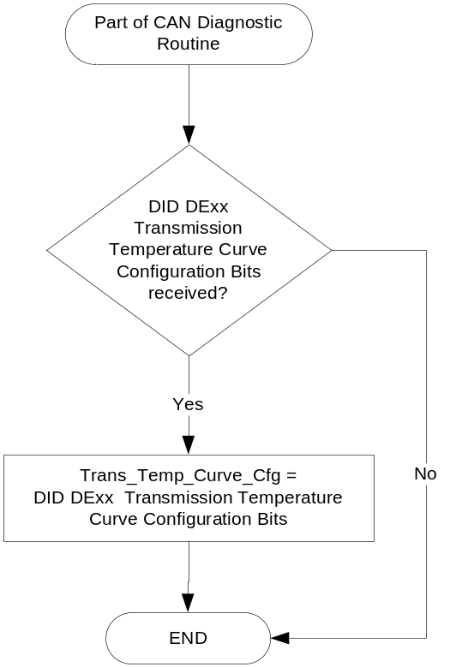
Figure 1.2 Gauge Control Algorithm

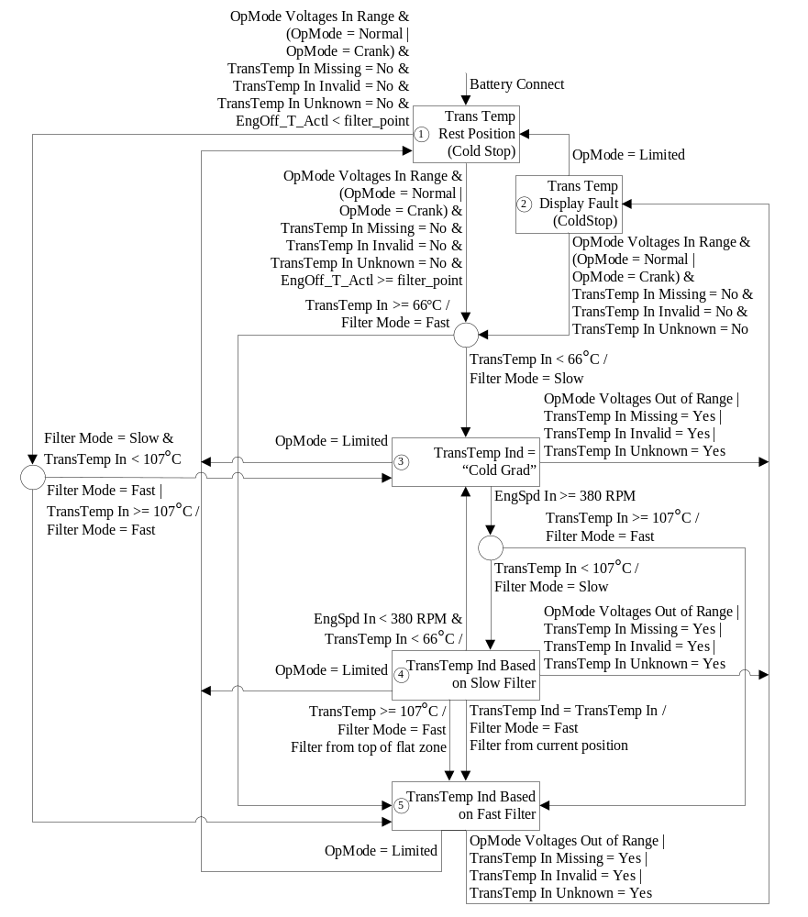

Operation Description (supports algorithm flowchart /state diagram)

Fast Filter
- The raw input temperature from the TCM/PCM shall be filtered by the cluster for smooth and continuous pointer movement.
- The Transmission Temperature Gauge shall not exhibit pointer waiver exceeding 1/3 of an angular degree with a steady commanded input.
- The Fast Filter shall be configurable to allow various filter rates.
- The Fast Filter constants shall reside in NVM or Flash ROM.
- The recommended initial filtering rate is one degree C per second.
- Filter shall be capable or rates from 0 – 5 degrees C per second with a resolution of 0.01 degrees C per second.

Slow Filter
- In the slow filter mode the displayed gauge value shall increase at a rate of 0.33 angular degrees per 5 second interval (i.e. 1 angular degree every 15 seconds).
- Filter shall be capable or rates from 0 – 8.33 angular degrees per 5 second interval with a resolution of 0.08333 angular degrees per 5 second interval.
- This movement shall be continuous and smooth until the slow filter mode is exited.
- Acceptable gauge filtering shall be as determined by jury evaluation.

Engine Off Timer
- Cluster shall receive EngOff_T_Actl from the BCM.
- If EngOff_T_Actl is missing, never received, or invalid ($FFFF), it shall be set to 65,534 sec
- A filter_point parameter shall be defined that the trans temp gauge logic shall use to determine whether to enter slow filter or fast filter mode

Function Safety Classification (EMC)

Class B

Memory Storage

Parameter Name | Description | Value at Battery Connect | Value at Module Wake-up
GboxOil_Te_Actl Signal | Filtered input temperature sent from the TCM | 0x0 | 0x0
Trans_Temp_Curve_Cfg | Parameter to select correct transmission temperature curve for transmission type. Controlled via CAN at EOL at VO plant | Do Not Init | Do Not Init
DIAG DID $6015 | DID used to read or short term adjust the gauge | 0x0 | 0x0
Operational_Mode | 4 state indicator for cluster operational mode | Limited | Limited or Normal or Crank
Filter Mode | Parameter decides which filter should be used. | Fast | Fast
filter_point | Used to compare EngOff_T_Actl | $708  (1800 Seconds)  (30 minutes) | $708  (1800 Seconds)  (30 minutes)

Prove Out

No

Error Handling

Missing Message Strategy

Missing Message Strategy

The signals will be declared missing as per the Diagnostics section of this SPSS.

DTCs states and history will be determined as per the Diagnostics section of this SPSS.

This strategy shall only be applied when the Transmission Fluid Temperature gauge is present.

Invalid Message Strategy

The signals will be declared invalid as per the Diagnostics section of this SPSS.

DTCs states and history will be determined as per the Diagnostics section of this SPSS.

This strategy shall only be applied when the Transmission Fluid Temperature gauge is present.

Unknown Message Strategy

The signals will be declared unknown as per the Diagnostics section of this SPSS.

DTCs states and history will be determined as per the Diagnostics section of this SPSS.

This strategy shall only be applied when the Transmission Fluid Temperature gauge is present.

Diagnostics

Self Test

None

Engineering Test Mode

Reference section “Dealer / Engineering Test Mode (ETM)”

Part II Performance

Reference Part II Diagnostic Specification

Supported ISO14229 Diagnostic DIDs
Number | DID / CommonID Name | DID Type
6015 | Transmission Temperature Gauge Pointer Position - Commanded | Unsigned Numeric in degrees Celsius

Note, changed from DID 6015 to 601D to use percent of gauge sweep to be more consistent with other minor gauges.

Number | DID / CommonID Name | DID Type
601D | Transmission Temperature Gauge Pointer Position | Percentage of gauge sweep. 0 is “A”, and 255 is “L” (100%).

Supported Diagnostic Trouble Codes (DTCs)

DTCs shall be logged as per the diagnostic section of this SPSS.

DTC | Description
C10100 | Lost Communication with TCM
C40200 | Invalid Data Received from TCM
C40281 | Invalid Data Received from TCM

DID DExx
Block  Num | Block Description | Byte(s) | Bits | State: Description | "0" | "1" | Default | Comments/Information
PACKETED BLOCKS
$xx | Option Content (B&A) | * | 2 | Transmission Temperature Curve | encoded | encoded | 0x0 | This cfg bit is used to select between transmission temperature curves for the Trans Temp Gauge. The 3 current curves are for automatic transmissions.  Set per transmission type. Table A has highest start of yellow band.
0x0 – Table A:
10R80, 8F24, 8F57, 9F35, 9F40, 8F35
0x1 – Table B:
10R100, 10R140, 6F55, 6F50, 6F35, 6F15
0x2 – Table C:
6R80, 6R140, 6R100, HF35, HF45
 |  |  |  | 0x3 – Not Used, software will use Table A (treat as 0x0)
 | *Byte and bit location to be identified in Part II Specification for this cluster

Reference Specification

IS-0015 INSTRUMENT AND GAUGES PERFORMANCE
IS-0033 GAUGE DURABILITY
IS-0052 OPERATING VOLTAGES – FUNCTIONAL/PERFORMANCE
IS-0103 SYSTEM AUDIBLE NOISE
IS-0319 TEMPERATURE GAUGE (ECTI)
IS-0379 NORTH AMERICAN WARNINGS AND INDICATORS STRATEGY
RQT-070100-021376 Transmission Temperature Gauge Constraints

Revision History

SPSS Module Revision History

Revision Level | Name | Change Description | Date
1.0 | V.Patel | Updated for CGEA 1.3 based on CGEA STSS v2.4  Section 1.2.2 – Removed table referencing the HS-CAN messages that contains the input signals.  Section 1.4 – Rewritten. Deleted references of specific missing, invalid and unknown message flags and timer.  Section 1.5.3 – Deleted DTC logging criteria from table. | 4/6/2010
1.1 | A. Venuturupalli  S. Watkins | Section 1.2.2, Table 1.2 – Corrected the units to sec^0.5 as per Denso Q&A #79 (P558 MY17) | 10/1/2014
2.0 | S.Watkins | Per feature owner Jim Gooden and DI Change Control on 4/7/2016 we agreed to use up to 4 look up tables globally for this feature. At this time, we are moving from 1 table to 3 tables for the new 10R80 and 8 and 9 speed transmissions.  - Section 1.1 – Modified description  - Section 1.2.1 – Modified Figure 1.1 to add Trans_Temp_Curve_Cfg  - Section 1.2.2 – Added Trans_Temp_Curve_Cfg  - Section 1.3.3.2.2 – Modifed existing table and added 2 new tables to line up with the new config.  - Section 1.3.5.1 – Modified Figure 2 to add config  - Section 1.3.5.4 – Added config  - Section 1.5.3 – Changed form DID 6015 to 601D to use a percentage of gauge sweep to be consistent with other minor gauges. Also added new DExx config. | 4/20/2016
2.1 | S. Watkins | This version just adds more tranmissions to the configuration list for clarity. NO NEED TO DCR.  Official SDS cascaded from Jim Gooden, RQT-070100-021376 Transmission Temperature Gauge Constraints.  - Section 1.1 – Added “RQT-070100-021376” to the description.  - Section 1.5.3 – Added 6 more tranmission types to the DExx description.  - Section 1.6 – Added Added “RQT-070100-021376” to the reference. | 6/7/2016

